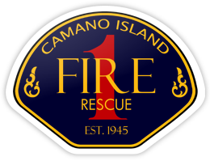
CHIEF’S REPORT
October 24, 2022

Presentation: Volunteer Program – Doug ten Hoopen
Administration:
- Strategic Planning / Standards of Cover Update
  - Meeting re: SOC recommendations
  - Draft SOC due this week. Presentation at next Board meeting
  - Will incorporate SOC recommendations in Strategic Plan Final Draft
- Island County Chiefs – Master Mutual Aid Agreement
- Betty Phillips Donation
- Organizational values team training
- Fiber optic installation
Personnel:
Operations and Training:
- Spenser Mezzone Pump Operations
- Rope rescue – new equipment and training in action
Community Outreach:
- CERT Training – Thanks to PM McIntosh, FF O’Hara, FF Ludden
- Coloring contest winners – Thanks to Christy Mathews
- Halloween Haunted House

