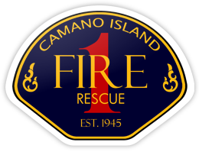
CHIEF’S REPORT
November 14, 2022

Presentation: Standards of Cover – Dr. Steve Knight
Administration:
- Strategic Planning / Standards of Cover Update
- Facilities Update
  - Fiber Project
  - Station signs
- Falls Prevention Program
- Organizational values development update
Personnel:
Operations and Training:
- Cadaver Class
- November windstorm
- ALS/BLS Protocols
Community Outreach:
- Halloween Haunted House – Thanks to Mabana Flames, Camano Preparedness Group, CIFR Volunteers and Cadets
- Update to Mabana Flames
- Cell phone charging at Station 5 – Partnership with Flames and CPG

