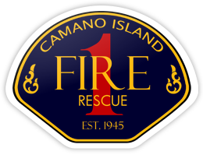
CHIEF’S REPORT
January 8, 2024

Presentation: Northwest Incident Support / Peer Support – Julie Boyer, Lt. Mauck

Administration:
- NextRequest
- Leadership Academy Wrap-Up
- Station 5 Project Update
Personnel:
- Hiring Update
- Paramedic Training Update
- Schweiger / Webb Last Call and Retirement
Operations and Training:
- Significant Incidents – AC Allen
Community Outreach:
- Santa Run

