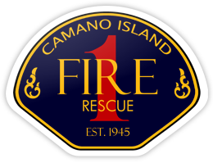
CHIEF’S REPORT
February 12, 2024
Presentation: Fire Cadet Program – Erich Schweiger

Administration:
- Chief’s Report Presentations for 2024
- NextRequest
- VOIP
- Meeting with NWRC and Senior Center
- Northwest Incident Support
- Island County Chief’s, EMS, ICOM TAC
Personnel:
- Hiring Update
- New FF Update
- Mike Fox-Ramey complete Paramedic Certification
Operations and Training:
- Significant Incidents – AC Allen
- Battalion Chief Implementation
Community Outreach:
- Mabana Flames
- Levy Committee Wrap-Up

