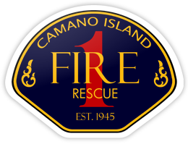
CHIEF’S REPORT
April 8, 2024
Presentation: Maintenance Division – Jay Jacks

Administration:
- New volunteer for CIFR Mobile Integrated Health Care
  - Meeting with Camano Center
  - Meeting with Northwest Regional Council
  - Meeting with ICPH on Camano (including new PH Nurse)
  - Resource library, home visits, referral system
  - ISR Meeting this week
- Island County Public Health Community Health Assessment
- VOIP – Fully implemented
- ESO Conference
- Northwest Incident Support Update
- Island County Master Mutual Aid Agreement
- Island County Fire Inspections
- Facilities Update – Chief Helgeland
  - Driveway access to upper properties
  - Station 4 HVAC

- National Public Safety Telecommunicators Weel (4/14-4/20) – Visit on 4/15
Personnel:
- Hiring Update
- New FF Update
- Volunteer Program Update
Operations and Training:
- Significant Incidents – AC Allen
- Ready Rebound Kickoff
- Harborview PM Training – PM Testing April 25th
Community Outreach:
- Annual Report Final Draft

Facilities Committee (Station 5):
- Signed PSA with Carletti Architects
- Meeting with Commissioner St. Clair regarding project
- Meeting with Commissioner St. Clair and Chief Helm re: Permitting Challenges
- Initial meeting with Carletti Architects:
  - Review Site Plan
  - Review Preliminary Program
  - Review Schedule
  - Discuss options
  - Preliminary meeting with Island County Planning on 4/22

